Watauga County Cooperative Extension Apple Tree Sale 2023
Old Fashioned Heirloom Apples: Bare root plants, orchard ready, 2 yr., approximately 4-5 ft tall usually unbranched. Will reach 15-20 ft. at maturity: Grafted which means the top part is an heirloom apple variety, the top is joined together with a root system from a variety called m-111, a semi-dwarf root system that is resistant to diseases and will keep the tree from growing as tall as the heirloom variety (35ft or more)
- Space 15 feet apart, 4-5 years to significant fruit production, but will get some fruit sooner.
- All apples are heirloom varieties (Except Goldrush) that have a history of being grown locally in the southern Appalachians. No longer commercially grown, we are wanting to preserve our local agricultural heritage. These apples are well suited to our environment.
- Most apple trees need another variety to cross pollinate for optimum fruit production, the neighbor’s apple trees and even seedling apple trees nearby help with this pollination. A few varieties are self-fertile. Plant apple varieties that bloom at the same time. A really early apple will not pollinate a very late apple.

APPLE, HARVEST, USAGE | PHOTO | DESCRIPTION | HISTORY/MISCELLANEOUS
Fallawater  October harvest  Good for baking, dries well, fresh eating. | 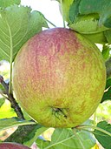 | Large to very large with dull green skin shaded with red. Flesh greenish white, coarse and with rich mild slightly sweet flavor. | - Originated in Pennsylvania around 1842.  - Grows well at higher altitudes in the south.  Keeps well, stores into Feb. in refrigeration.
Goldrush  October harvest  Fresh eating, juice | 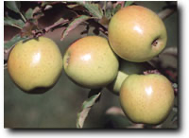 | Smooth skinned, thin to med. skin thickness, ovate in shape, greenish-yellow with an occasional bronze to red blush at harvest, becoming entirely deep yellow in storage. nonwaxy. Flesh is medium-coarse-grained, firm, crisp, and non-browning. Flavor is spicy, and sprightly acid at harvest. | - Modern variety bred for resistance to apple scab.
Gragg  Sept. / October  Good for cooking  Good keeper |  | Medium sized fruit, bright red on the sunny side, overlaid with darker red stripes, flesh slightly greenish, and juicy with a sub-acid flavor. | - Originated on James Gragg’s Farm in Caldwell County over 50 years ago.  - Tree is thrifty, needs little pruning and is a good bearer.  - One of the varieties that was grown on the Moses Cone Estate, as well as grown by settlers of the Newland area.
Old Fashioned Winesap  October/November  Stays firm in baking, cider, fresh eating  Stores 3 months or more | 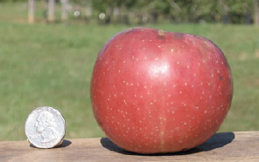 | Medium sized, dark yellow skin with stripes of dark red, yellow flesh is crisp, firm, juicy, sweet. | - Originated New Jersey about 1800, well-known in the South.  - Described in 1887 as standing unrivaled, combining more excellent qualities than any other apple we know.
Summer Orange  Late August/September  Pies, cooking, fresh eating  Stores 3 months in cold |  | large, roundish conical, skin pale yellow, sometimes with a pinkish or brownish blush or some russet splotches. Dots conspicuous. Flesh white and moderately fine grained. Crisp, tender, juicy, aromatic, subacid. | - Also known as Fall Orange, Hogpen, New York Bellflower  - Sold by a small NC nursery in the 1920’s  - Productive every year and moderately resistant to fire blight.
Summer Rambo  August-Sept  frying, pies and applesauce | 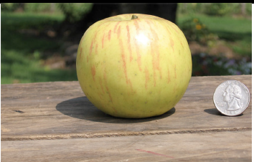 | large and is often ribbed with unequal sides. Skin is greenish yellow washed with pink and carmine on the sun exposed side. The greenish yellow flesh is tart, coarse, tender and very juicy. | - This apple is of French origin popular in the south  - The fruit can be picked while still green for frying, pies and applesauce. Firm when cooked.
Swiss Limbertwig  October  Excellent for fresh eating, cider, firm when baked  Good Keeper | 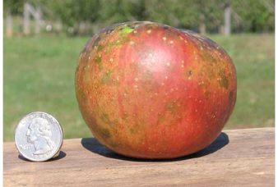 | Medium size, square and compact, somewhat rough to touch, beautiful maroon color with some yellow, and white dots. Crisp, unusual sweet flavor with notes of citrus and a cane sugar aftertaste. | - Originated 1700’s grown by Swiss settlers in Cumberland Mtns.  - The name limbertwig comes from the weeping habit when they are covered in fruit.  - Easy to grow.
Virginia Beauty  October harvest  Good for fresh eating, drying, and cooking, firm when baked.  Good keeper | 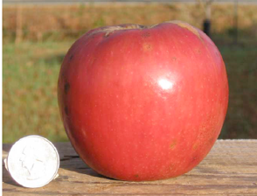 | Medium to large, conical shape, dark red to purplish skin, fine grained, tender crisp flesh, juicy, mildly subacid to almost sweet. | - Originated about 1810 in Piper’s Gap Community of Carroll Co, VA by Zach Safewright.  - Classic mountain eating and pie apple.  - Resistant to fire blight, mildew and has wide branch angles.
Winter Banana  Sept.-October  Fresh eating, dessert apple, cider | 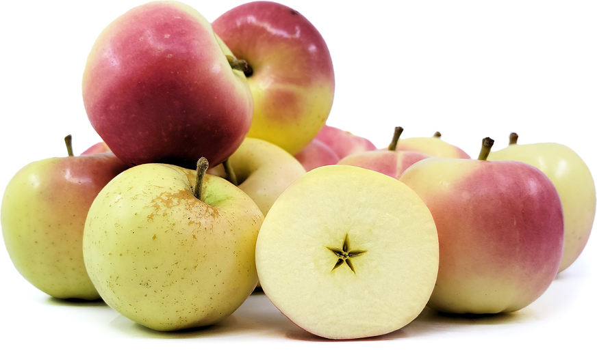 | smooth, waxy, pale yellow skin and pinkish-red blush, the Winter Banana is an extremely attractive apple  mild, sweet flavor. highly aromatic apple with a pleasant, perfumed aroma that some people discern as banana. | - Diploid, self-fertile apple, meaning that it not only pollinates itself, but also serves as a very effective pollinizer for other apple trees.  - Late bloomer, a trait which can protect it from the occasional late spring freeze.  Precocious apple, often producing fruit in the second or third year after planting.
Wolf River  September-October  Good for sauce/apple butter, fresh eating, drying | 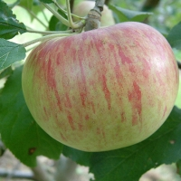 | Large, irregular in shape, greenish yellow color, red and carmine stripes, flesh coarse grained and moderately juicy, complex sweet/tart flavor. | - Well-known in Southern Appalachians, originated about 1870 along Wolf River, Wisconsin.  - Frost hardy and generally disease resistant.  - Fairly easy to grow stores 1-2 months.
Yellow Transparent  Late June/July harvest (earliest apple)  Most well known for its excellent clear apple sauce | 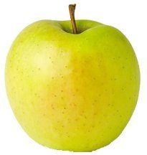 | Medium size, transparent yellow skin, tender fined grained and juicy, sweet and tangy. | - Originated in Russia and imported by the USDA in 1870.  - Easy to grow and disease resistant but not good for storing.  - Pick while green for best flavor.
Pumpkin Sweet  Late August / Sept.  Cooking, Apple Butter, fresh eating | 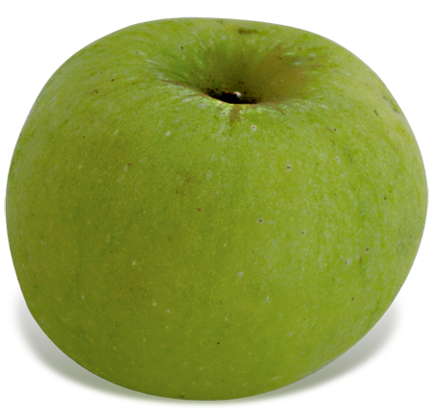 | Large to very large, roundish to conical, ribbed, yellow to green with a golden brown blush on the sunny side. Patches of russeting at the top. flesh is white tinged with yellow, firm, crisp, not very juicy. Mild, very sweet flavor. | - 1830s, Connecticut but it has tended to be more popular in the South  - Also known as Pound Sweet.

