2023 Fruit Plant Descriptions
For more information including recorded classes visit this link:
https://drive.google.com/file/d/14VDevZRqBNCL9vggxBKFBGXS_Pp3lobf/view?usp=sharing

If you aren’t able to access this link or have additional questions, send an email to: http://wataugmastergardener@gmail.com

Printed information is available in our lobby.

Thornless Blackberries: Are grown in 5 inch plugs shipped dormant pictured to right, sometimes will be completely dormant with no leaves  - All are self-fertile, do not require 2nd variety for fruit.  - Floricane varieties produce fruit on previous season’s growth. The cane must be left over the winter. The primocane variety makes fruit on the current season’s growth, producing fruit at the end of the summer. Can be cut to the ground in fall or spring or can be left to produce a summer crop instead. |  |  |  |  |  | 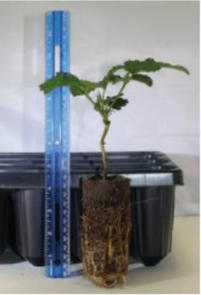
Variety | Season |  |  |  | Description
‘Natchez’ | Mid July  Floricane  (Produces fruit on previous season’s growth) Prune selectively |  |  |  | Due to its semi-erect growth habit, Natchez performs best with a trellis. This is the earliest ripening thornless variety with very high production potentials. Very large and good tasting berries can be harvested during a 3–5-week season beginning mid to late July.
‘Ouachita’ | Mid July/early August  Floricane  (Produces fruit on previous season’s growth) Prune selectively. |  |  |  | Upright, very erect canes. Large, firm, sweet, attractive berries, with proper summer pruning needs minimal trellising. The most widely produced commercially.
‘Triple Crown’ | Latest of the Floricane varieties, around mid-August.  Floricane  (Produces fruit on previous season’s growth) |  |  |  | Joint release from the USDA-Beltsville and Pacific West Ag. Research Service. The plant is semi-erect and bears large, moderately firm, flavorful fruit. Needs trellising.
‘Prime Ark Freedom’ | Fall  Primocane (Produces fruit on new growth, can be cut to ground each year) |  |  |  | Newer introduction by University of Ark. Med-Large berries. To produce earlier fruit and increase yield, manage height by tipping an inch off each new stem as the new growth reaches 12-15”. Tip again when branches reach 30”. Can be pruned as a floricane variety to produce summer crop.
Blueberries: 2–3-year-old plants in 1 gal pots  - Plant 2-3 different varieties for increased production. Space 5 ft apart.  - Consider using in the landscape as a shrub to provide spring flowers, summer berries, and fall color.  - pH 4.5-5.0  - For more information on growing blueberries: https://blueberries.ces.ncsu.edu/blueberries-home-gardeners/ |  |  |  |  |  | 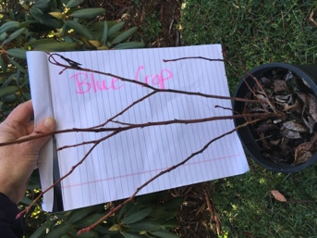
Variety |  | Season (beginning around late June going through August) |  |  | Description
‘Duke’ |  | Early |  |  | Open erect habit 4-6 ft., uniform medium to large firm fruit, excellent for fresh eating, maintain flavor well in storage. Early producing variety but blooms late enough to normally avoid late freezes.
‘Patriot’ |  | Early midseason |  |  | Fruit is firm and very large with very good flavor. A late bloom date avoids many frosts, still produces a large, early crop.
‘Blue Crop’ |  | Mid-season |  |  | The leading commercial blueberry variety. Known for its hardiness, vigor, and consistent production. The plant is upright and grows to a height of 4-6 feet. High yields of med-large, bright blue berries in large clusters. Firm, with superb flavor.
‘Blue Ray’ |  | Early midseason |  |  | Large, firm dark blue berries with excellent aromatic sweet flavor, desert quality, 4-6’ Upright spreading habit.
Raspberries: bare root  - Primocane varieties produce fruit on the current season’s growth and can be pruned non-selectively each year for easy maintenance. Canes of Floricane varieties must grow the first season, then will flower the following summer, so must remain during spring pruning, then be removed after fruiting.  - For more information on growing raspberries visit https://rubus.ces.ncsu.edu/rubus-home-gardeners/ |  |  |  |  |  | 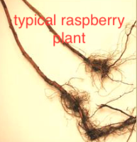
Variety/color |  |  | Season |  | Desc
‘Himbo Top’  Red |  |  | Late summer / fall  Primocane (prune all canes to ground in late winter) or selectively prune to produce a summer crop. |  | Introduced in 2008, has demonstrated high tolerance to Phytophthora root rot disease. This variety produces extremely large, firm, bright red fruit that does not darken. Berries have good flavor, are conic shaped, have small, well-constructed drupelets and are easy to pick.
‘Polana’  Red |  |  | Late summer / fall  Primocane (prune all canes to ground in late winter) or selectively prune to produce a summer crop. |  | Highly productive, medium/large, glossy in appearance, cohesive, with good flavor. This variety has short canes that are vigorous. One of the earliest fall berries, usually mid-August, leaving plenty of time to harvest before frost.
‘Double Gold’  Gold |  |  | Late summer/fall  Primocane can cut to the ground in late winter or selectively prune to produce a summer crop. |  | Release from Cornell University. The plant grows vigorously, suckers freely, and shows tolerance to diseases. The deep blush, golden champagne color berries are medium in size and have a conic shape. Excellent, sweet flavor.
‘Niwot’  Black |  |  | Late summer/fall  Primocane can cut to the ground in late winter or selectively prune for a summer crop. |  | This heirloom-quality variety was released from the Cornell Small Fruit Breeding Program. This black raspberry plant is a high-producing early variety whose upright growth and cluster formation make its berries very easy to pick. It has medium, firm, glossy fruit with the best black raspberry flavor. Moderately hardy but very vigorous, Bristol shows tolerance to powdery mildew
Grapes: Bare root  - Seedless, but note that they are slip skin, meaning the skin separates from the pulp, and is thicker than the grapes you buy at the grocery store. Like 'Concord' but without seeds.  - Breeding is being done at several universities to develop a non-slip skin seedless grape, but at this point there is not a variety that also provides other desirable characteristics such as cold hardiness and disease resistance needed in our climate.  - For more information https://content.ces.ncsu.edu/grapes-and-berries-for-the-garden |  |  |  |  |  | 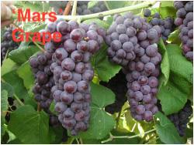
Variety |  | Season |  |  | Description
Mars |  | Mid-Season |  |  | Highest producing grape in NC State table grape study. Medium-sized clusters of med-large slip skin berries that turn from crimson to deep blue at maturity. Thick slip skin, resistant to cracking. Fruit holds well on the vine and is suited for extended periods of harvest. Resistant to black rot, not sensitive to sulfur.
Asparagus: Bare root plants 12 per bundle (1 yr. plants that meet standards for 2-year plants)  - Perennial crop, do not harvest first year, harvest lightly the 2nd  - Likes a high pH between 6 and 7, test soil, add lime  Visit for more info https://content.ces.ncsu.edu/asparagus |  |  |  |  |  | 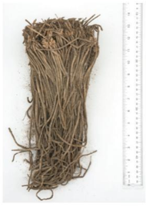
Variety
Millennium |  |  | Spring | Developed by Univ. of Guelph, Canada. High quality spears, tender, and has good flavor. Can tolerate a wide range of soil conditions
Strawberries: Bare root 25 per bundle  - June bearing varieties produce one heavier crop for 2-3 weeks in summer, and produce more runners, requiring yearly stand maintenance.  - Everbearing will produce less fruit at one time, but fruiting will continue from about 12-14 weeks after planting until frost.  - 12”-15” between plants  For more info NC State Extension Strawberries in the Home Garden |  |  |  |  |  | 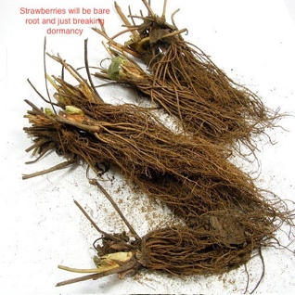
Variety |  |  | Season |  | Description
Sparkle |  |  | June bearing: one large crop for 2-3 weeks, in mid to late June. |  | Best for freezing, canning, and making preserves. Large berries with superb flavor. Heavy producer, adaptable to a wide variety of growing conditions. June bearer blooms are susceptible to late frost. For this reason, we chose a variety that blooms the latest of the June-bearers, however there may still be a risk of crop loss due to late freeze. Plants need to be cut and thinned after bearing. Matted row bed expected to last 3-5 years, remove blooms the first year
San Andreas |  |  | Everbearing: late summer, less fruit at one time over a longer period |  | Some people prefer this type of bearer for fresh eating because they produce over a longer period. Large berries with nice firmness, some berries tend to be asymmetrical, excellent overall disease resistance. Do not require yearly bed renovation. Recommended to replace planting every 1-2 years. Produce fruit the season they are planted.

