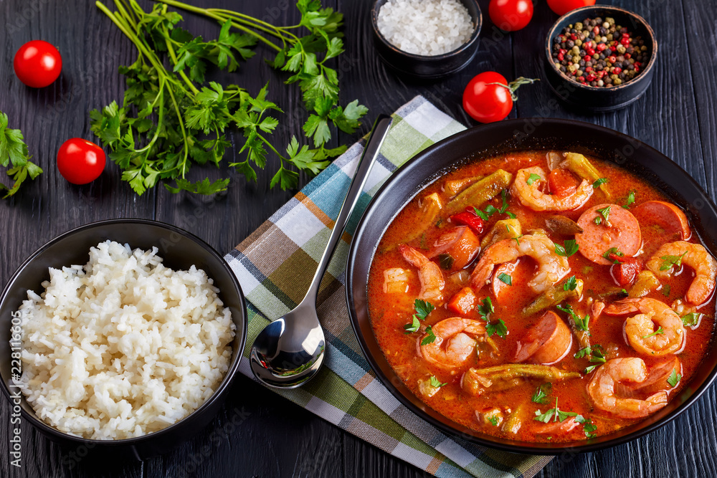

½ cup oil

½ cup flour

2 pounds okra, sliced

2 cups onion, chopped

1 cup celery, shopped

1 cup green pepper, chopped

4 cloves garlic, minced

Either: 1, 6 ounce can tomato paste or 1 medium tomato, chopped

3 bay leaves

½ teaspoon Tabasco sauce

¼ teaspoon cayenne pepper

2 tablespoons parsley, chopped

1 tablespoon Tony Cacheres Creole Seasoning

8 – 10 cups hot water, chicken, shrimp or fish stock to adjust thickness

3 pounds shrimp, peeled raw

1 pound picked crabmeat (may use canned)

1 pound smoked sausage, sliced

6 cups cooked long grain rice

In a cast iron skillet, heat oil over medium heat. Add flour and stir frequently until roux is a copper color. Set aside.

In another skillet, cook sliced sausage and set aside.

Place a large pot on the burner and heat 4 tablespoons of oil. Add okra, onions, celery, green pepper and garlic. Sauté for 20 minutes on medium high heat. Add sausage, tomato paste or tomatoes and continue to cook another 5 minutes. Add the water or stock then incorporate the roux. Stir well and bring to a boil. Add the crab meat. Reduce to a simmer and cook an additional 2 hours.

Return gumbo to a boil, then reduce to simmer. Add shrimp and cook until they turn pink, just a couple of minutes. Remove from heat. Place some cooked rice in a shallow bowl and top with gumbo. Enjoy with fresh baked baguette.

Recipe by Leone LeBlanc D’Arensburg (Rita Bolick’s great grandmother)

**New Orleans-Style**

**Seafood Gumbo**



margie_mansure@ncsu.edu