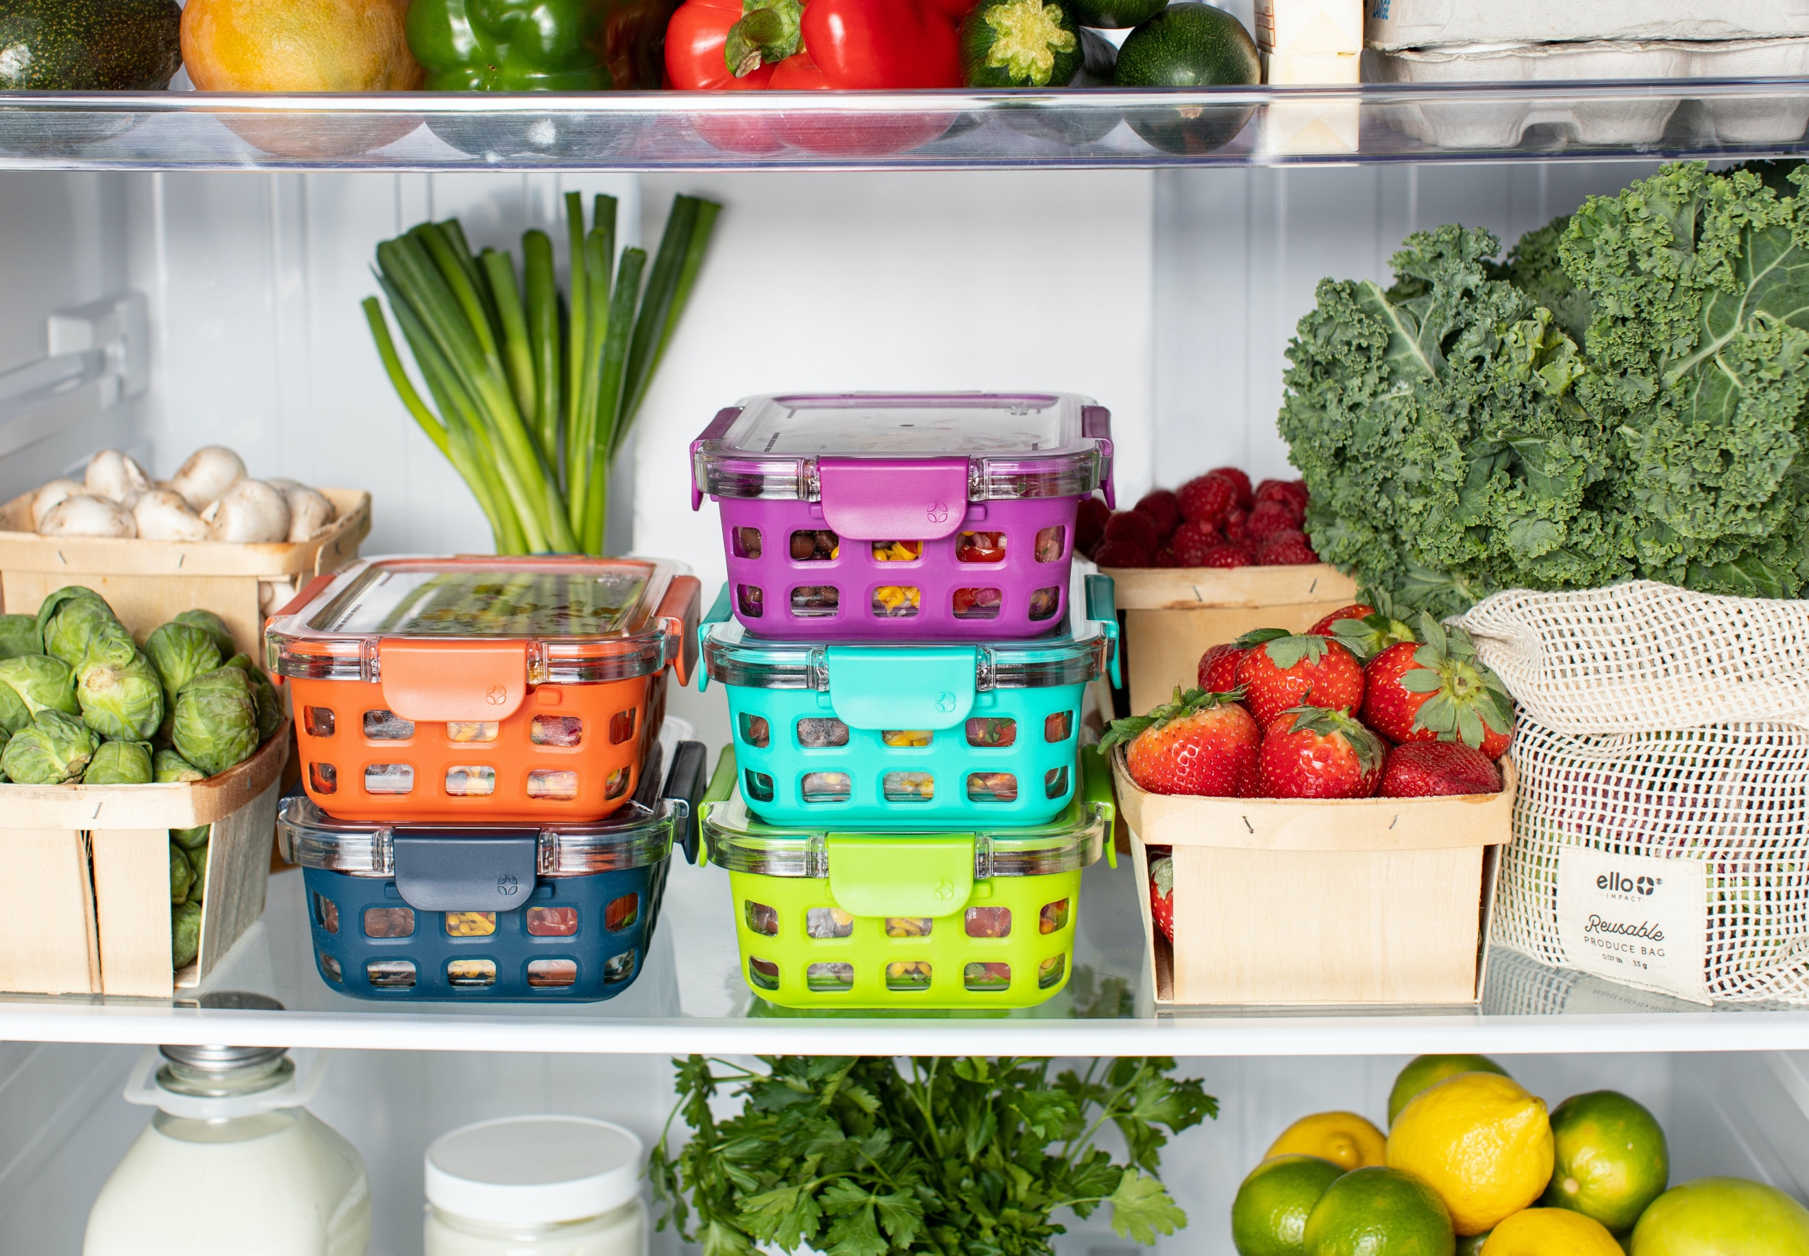
Meal Prep and Planning Tips
Make a list of your favorites for breakfast, lunch and dinner. Refer to this list during your meal planning before grocery shopping.

Use easy, health promoting recipes that you repeat every week. Could even be on the same day each week, like “taco Tuesdays”, and “Friday pizza night”. Have a pantry stocked with essential ingredients for these meals, and purchase the same perishable items each week.

For a plant-forward approach add more fruits and veggies to meals. Consider onions and bell peppers in taco meat, extra veggies on pizza, fresh spinach and peppers added to spaghetti sauce, or chopped mushrooms mixed into lean hamburger meat.
Cook large portions of vegetables and protein as your schedule allows. For the next several days, add a starch, like rice or quinoa and a sauce to create a bowl. Or assemble a salad, burrito or pasta dish with your ingredients.

When you have spare time, chop and slice ingredients so they’re ready-to-go for quicker meal prep the next few days.

As your schedule allows, cook large batches of soup, casseroles and other dishes that freeze well. Divide into meal-sized portions. This way, you eat one or two meals that are the same and then pull meals out of the freezer for more variety each week.

Cook once, eat twice. Cook large batches of favorite recipes so that you have left-overs for dinners and/or lunches.

margie_mansure@ncsu.edudu

